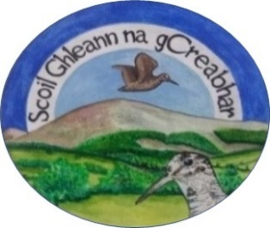
Anglesboro N.S. - Registration Form

Tel No: 062 46697 Roll No: 17981K
Email: anglesborons@gmail.com www.anglesborons.com

Please complete in BLOCK CAPITALS

Pupil's Name: |  | Date of Birth:
Male/Female: |  | P.P.S. Number:
Address: |  | Country of Birth
Nationality: |  | Year of arrival in Ireland if born outside the country
Eircode |  | Languages spoken in the home
Mother’s maiden name: |  | What is your child’s religion:
Parent/Guardian Details |  | Parent/Guardian Details
First Name: |  | First Name:
Last Name: |  | Last Name:
Relationship to child: |  | Relationship to child:
Phone No (Home): |  | Phone No (Home):
Phone No (Work): |  | Phone No (Work):
Phone No (Mobile): |  | Phone No (Mobile):
email Address: |  | email Address:
Names of brothers/sisters in this school / will also be joining this school:

It is school policy to pass on the above information except Religion and Ethnicity to the Department of Education and Skills.

Please tick |  |  | Yes | No
Are there any orders or other arrangements in place governing access to or custody of your child?

The school may share Personal Pupil Data with other organisations such as HSE, Tusla, An Garda Síochána, etc where there is a legal basis for doing so under GDPR.

Name of Previous School/Pre-school:
Address:
Phone No:
Names of persons who have permission to collect your child at school or
in the case of illness or emergency (not the same as above)
Name: |  | Phone No:
Relationship to child:
Name: |  | Phone No:
Relationship to child:
Name: |  | Phone No:
Relationship to child:
Please tick |  |  | Yes | No
Have you attached a Birth Certificate for your child?

Relevant Medical Information:

Family Doctor: | Phone No:
Any medical concern/information of relevance? (use a separate sheet, if required)

Has your child any Special Educational Needs? Details:

